S. Bösch, N. Eckhart, R. Emberger and P. Meier

Tower Hopscotch

Project Analysis



Project Analysis – Tower Hopscotch

Table of Contents

1. Project Management 2

1.1. Previous Activities 2

1.2. Time Comparison 2

1.3. Risk List 2

2. Use Cases 3

2.1. UC 1 – Play game 3

2.2. UC 1.1 – Place tower 5

2.3. UC 1.2 – Upgrade tower 5

2.4. UC 1.3 – Tear down tower 6

2.5. UC 1.4 – Call next wave 6

2.6. UC 1.5 – Pause game 6

2.7. UC 1.6 – Unpause game 6

2.8. UC 2 – Create map 6

2.9. UC 3 – Edit map 6

2.10. UC 4 – Import map 6

2.11. UC 5 – Export map 6

3. Use Case Diagram 7

4. Domain Model 7

5. First Architecture 7

6. Additional Specifications 7

7. Sequence Diagram 7

8. Glossary 7

# Project Management

|  |  |
| --- | --- |
| Current Iteration | Iteration #2 [Elaboration Phase]  16. October 2017 – 27. October 2017 |
| Next Iteration | **Iteration #3 [Elaboration Phase]**  30. October 2017 – 10. November 2017 |

## Previous Activities

|  |  |  |  |  |  |
| --- | --- | --- | --- | --- | --- |
| Phase | It | Activity | Assignee | Expected Time [h] | Effective Time [h] |
| Inception | 1 | Create Project Outline | Team | 10hrs | 11.5hrs |
| Identify Use Cases | Team | 8hrs | 6hrs |
| First architecture determined | Team | 4hrs | 4hrs |
| Setup development environment | Team | 4hrs | 6hrs |
| Elaboration | 2 | Detailed analysis and formulation of all Use Cases | Team | 16hrs | 16hrs |
| Domain Model defined | emberrap | 2hrs | 1.5hrs |
| Create Project Analysis document | Team | 16hrs | 14hrs |

## Time Comparison

Our effective time expenditures were in expected ranges so we did not need to take any actions to compensate for lost time.

## Risk List

|  |  |  |  |
| --- | --- | --- | --- |
| Risk | Counter Measure | Likelihood of occurrence | Impact on Project |
| Code becomes hard to understand or maintain. | Follow clean code guidelines and have code reviews. | Low | Medium |
| Project complexity exceeding expectations resulting in increased time consumption. | Thorough analysis and detailed iteration planning. | Low | High |
| Lacking technical knowledge of one or more team members in a certain area resulting in increased time consumption. | Regular sharing of gained knowledge and assign tasks based on the developer’s skills. | Medium | Low |
| Loss of one developer for an extended period due to unexpected circumstances such as illness. | None | Low | High |

# Use Cases

The following use cases are prioritized from top to bottom. The biggest use cases “Play Game” was split up into smaller use cases to keep it organized and clear, because it’s the biggest and most time consuming one.

|  |  |  |  |
| --- | --- | --- | --- |
| Name | Details |  | Priority |
| 1. Play game |  | | High |
| * 1. Place tower | UC 1.1 – 1.6 are all use cases extending UC 1. Play Game. | | High |
| * 1. Upgrade tower | Medium |
| * 1. Tear down tower | Medium |
| * 1. Call next wave | High |
| * 1. Pause game | Low |
| * 1. Unpause game | Low |
| 1. Create map |  | | High |
| 1. Edit map |  | | Medium |
| 1. Import map |  | | Medium |
| 1. Export map |  | | Medium |

## UC 1 – Play game

**Primary Actor:** Player

**Stakeholders and Interests:**

* Player: Wants a stable framerate with short load times and no crashes to interrupt his experience.

**Preconditions:** The player has selected a map and started a new game on it.

**Post conditions:** The player has either defeated all enemy waves and won or his central structure has taken a critical amount of damage and has been destroyed resulting in the player losing the game.

**Main success scenario:**

1. The player has started a new game and the map is loaded.
2. The player spends his starting currency on building up his defenses.
3. The player clicks on begin, indicating they are done preparing and ready for the first enemy wave.
4. Incoming enemies are destroyed by the defensive structures and the player spends the money gained on new defenses.

*Step four repeats itself so long as there are enemies remaining in the current wave and the main structure has not been destroyed.*

1. When all enemies of the current wave have been destroyed, there is an indication that the next wave will be incoming soon.
2. The player has a set amount of time to improve his fortifications before the next wave begins automatically.

*Steps four through six are repeated while the last wave has not been defeated and the main structure has not been destroyed.*

1. The player has defeated the last wave and a message is displayed indicating that they have won the game.
2. The game automatically returns to the main menu after the message has disappeared.

**Extensions:**

*a. At any time, the game crashes:

The game shuts down and the player must restart the game if he wishes to continue playing. Any game progress will not be saved.

*b. The player closes the game window:

The current game ends and no game progress is saved.

*c. The Player pauses the game:

The ongoing game is paused, and a menu is brought up allowing the player to leave  
 to leave the game or to resume it.

**Special Requirements:**

* Windows or Mac computer with Java 8.
* Computer with mouse or a touch display.

**Frequency of Occurrence:** However often it is initiated by player.

## UC 1.1 – Place tower

**Main success scenario:**

1. The player selects a tower type to build. The selection is valid if the chosen tower type is unlocked and the players budget is not lower than the costs of the chosen tower type. If the selection is not valid, then the scenario ends here and can be restarted at any time.
2. The player selects a tile on the map to build the tower. The selection is valid if the chosen tile is neither a path tile nor is already occupied by another tower and can fit the tower in if the tower is multilayered (Towers spanning two layers can only be placed on the lower 2 layers. Towers spanning all three layers can only be placed on the lowest layer). If there is no tile available which could be selected, the scenario ends here and can be restarted at any time.
3. The tower gets built on the selected tile and its cost gets subtracted from the player’s budget.

## UC 1.2 – Upgrade tower

**Main success scenario:**

1. The player can upgrade a tower so that the tower makes more damage to the enemies. To upgrade a tower the player needs enough amount of money.
2. By clicking on an existing tower, a menu shows up with different upgrade possibilities like double damage, shoot faster etc. If the player doesn’t have enough money for a specific upgrade, the upgrade is still shown in the menu, but grayed out.
3. By clicking on the desired upgrade, the player loses money based on the cost of the upgrade and the tower gets upgraded.
4. The player closes the upgrade menu and is back in action.

## UC 1.3 – Tear down tower

**Main Success Scenario:**

1. The player clicks on the tower he wants to tear down.
2. The tower menu opens in which he can upgrade or tear down the tower.
3. The player clicks on the tear down button.
4. The tower gets destroyed and the player gets a fractional amount of the money he invested in building the tower.
5. The tower menu gets closed.

## UC 1.4 – Call next wave

**Main success scenario:**

1. When all enemies are defeated from the previous wave and the player has modified his defense, he can click on the button “Call Next Wave”. This results with the beginning of the next wave.

**Alternate Scenario**

When the player has defeated the last wave of enemies, the player can’t call a next wave because he has won the game.

## UC 1.5 – Pause game

The player can pause an ongoing game to stop all ongoing actions until resumed.

## UC 1.6 – Unpause game

The player can resume an ongoing game from a paused state to continue playing.

## UC 2 – Create map

The player can create custom maps for him to play on.

## UC 3 – Edit map

The player can edit his custom maps.

## UC 4 – Import map

A map can be imported from a chosen directory to be used or edited in the game.

## UC 5 – Export map

The player clicks on the “Export Map” button and the program exports a selected map to a chosen file location.

# Use Case Diagram

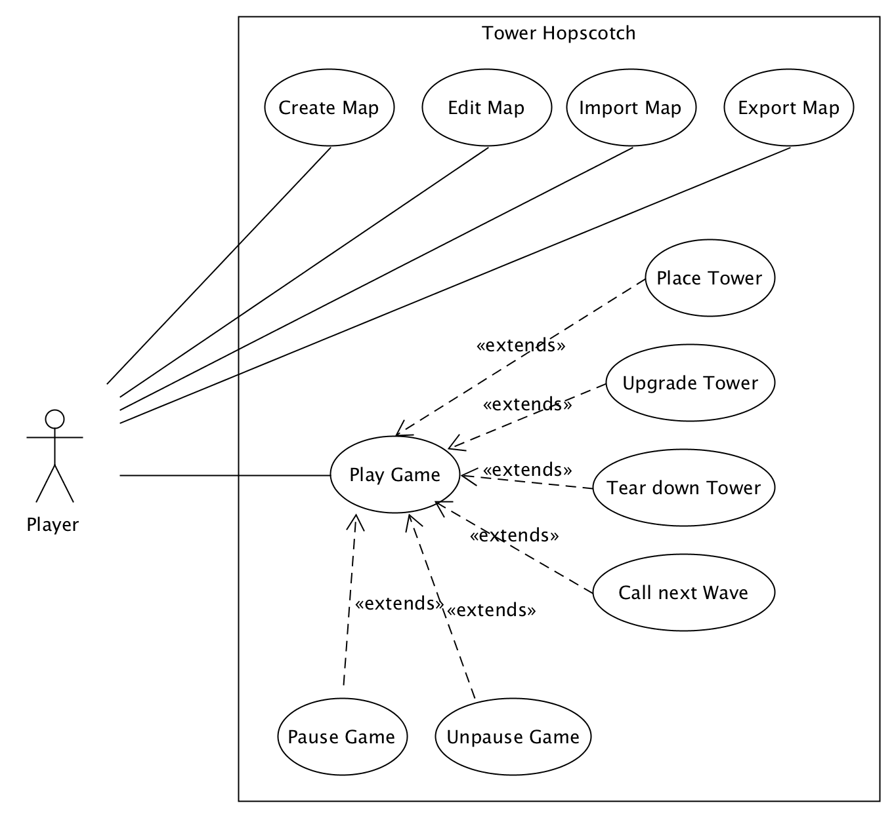

# Domain Model

# First Architecture

# Additional Specifications

# Sequence Diagram

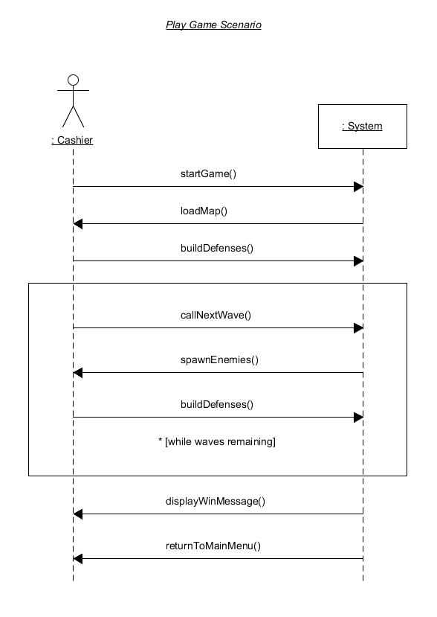

# Glossary

|  |  |
| --- | --- |
| Term | Definition |
| Castle | The players central structure, the defense of which is the games main objective. |
| Tower | Any of a variety of defensive or offensive building created by the player to hinder or destroy incoming enemies. |
| Wave | A wave refers to a group of enemies. A game encompasses multiple waves that need to be defeated. |